## Actor goal list

|  |  |
| --- | --- |
| Actor | Goal |
| User/Student | -Access system  -View directory of rooms  -Make a reservation  -Cancel a reservation  -Modify a reservation  -View list of reservations in the registry (view availability of rooms) |

Figure 1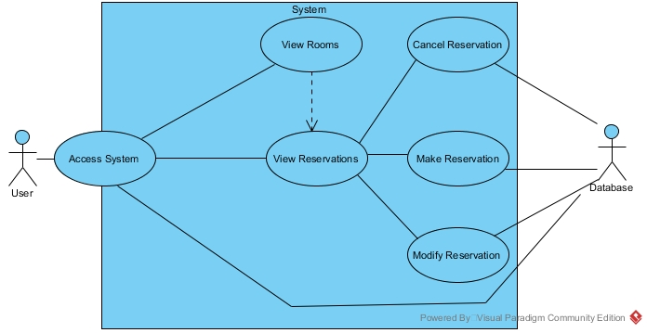

Figure 1. Use case model.

## Reliability

-The mean time between failures shall exceed 1 month.

*Note: In testing the system, we can shorten or prolong this amount of time, since it is currently difficult to determine*

## Usability

-The reservation system must be available to use from any commonly used web browser application (and relatively recent version).

*Commonly used web browsers: Google Chrome, Firefox, Internet Explorer, Opera, Safari, Microsoft Edge.*

-The reservation system shall be accessible to any type of student, regardless of department.

-Users will only be allowed to make a reservation in another room after already making one, once every 5 minutes.

-Users will only be allowed to add themselves to a single waiting list once every 2 minutes.

-Users cannot exist in a single waiting list more than once.

-Users cannot maintain more than 3 reservations for a single week period.

-Users may hold a position in any number of waiting lists for reservations, so long as they have not already reached the maximum number of reservations for the week (currently 3).

-Users holding the top position in a waiting list queue will be given the reservation for that room and timeslot if the current holder cancels their reservation.

-Users given a reservation for a room will be removed from all other waiting lists if they have reached the maximum allotted reservations for the week.

*Note: Timeframe and numbers are subject to change upon negotiations*